DATE:-3 JUNE 2026
import com.mongodb.client.*;
import com.mongodb.client.model.Filters;
import com.mongodb.client.model.Updates;
import org.bson.Document;

public class MongoCrudExample {

public static void main(String[] args) {

MongoClient mongoClient =
MongoClients.create("mongodb://localhost:27017");

MongoDatabase database =
mongoClient.getDatabase("CollegeDB");

MongoCollection<Document> collection =
database.getCollection("Students");

Document student = new Document("id", 101)
.append("name", "John")
.append("department", "CSE")
.append("cgpa", 8.7);

collection.insertOne(student);
System.out.println("Document Inserted Successfully");
System.out.println("\nStudent Records:");
FindIterable<Document> students = collection.find();

for (Document doc : students) {
System.out.println(doc.toJson());
}

collection.updateOne(
Filters.eq("id", 101),
Updates.set("cgpa", 9.2)
);

System.out.println("\nDocument Updated Successfully");

Document updatedStudent =
collection.find(Filters.eq("id", 101)).first();

System.out.println("\nUpdated Record:");
System.out.println(updatedStudent.toJson());

/*
collection.deleteOne(Filters.eq("id", 101));
System.out.println("\nDocument Deleted Successfully");
*/

mongoClient.close();
}
}
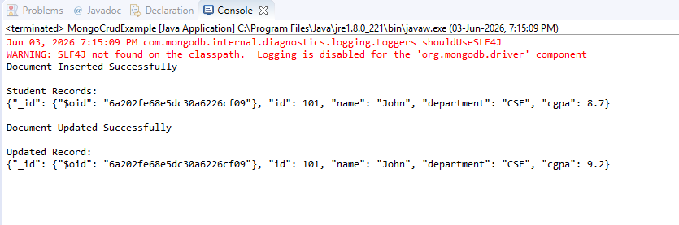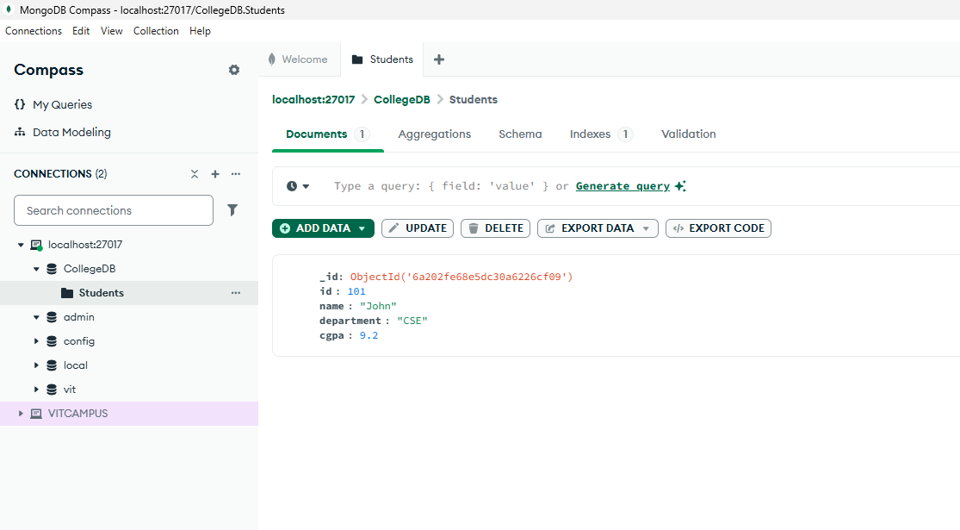
Now DELETE PART
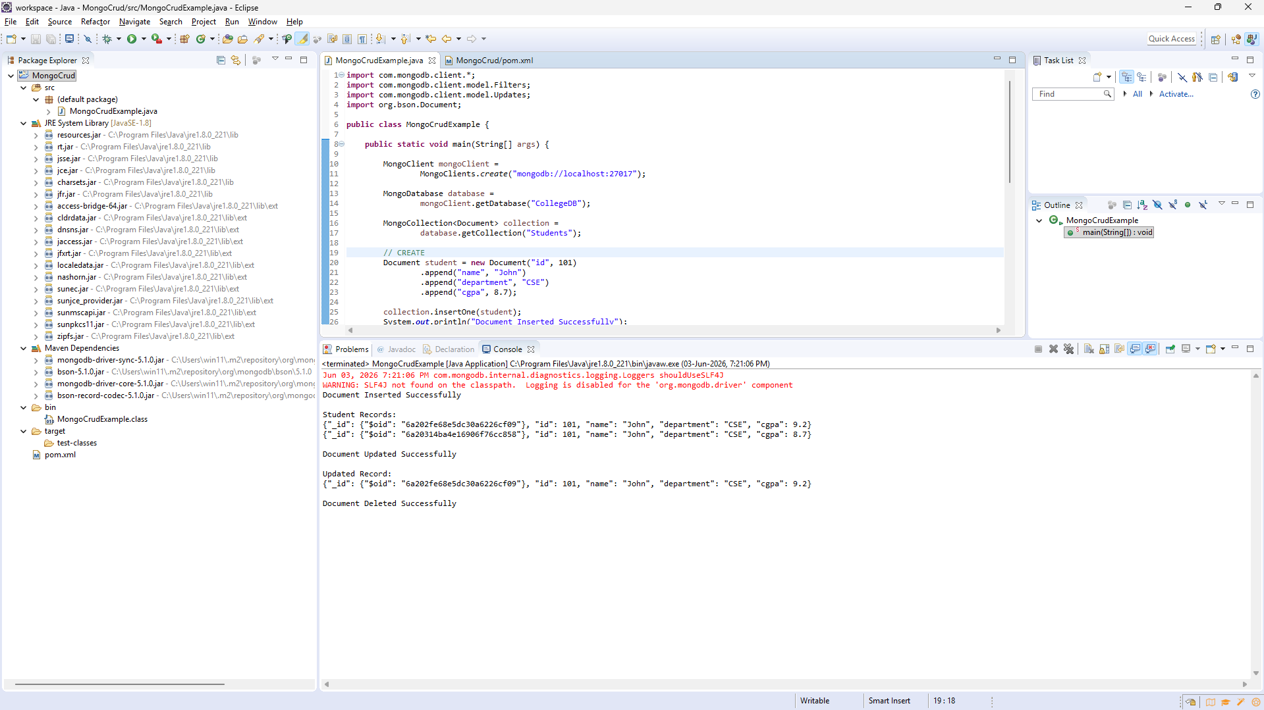
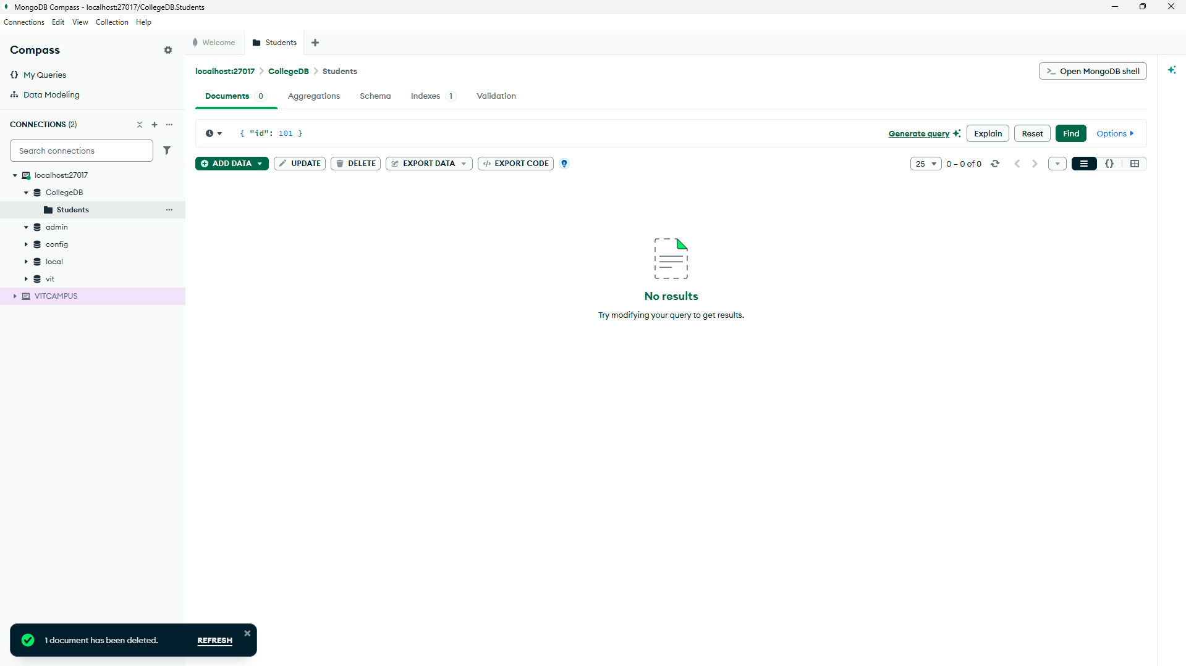
INSERT MANY
import com.mongodb.client.*;
import org.bson.Document;

import java.util.Arrays;
import java.util.List;

public class MongoCrudExample {

public static void main(String[] args) {

MongoClient mongoClient =
MongoClients.create("mongodb://localhost:27017");

MongoDatabase database =
mongoClient.getDatabase("CollegeDB");

MongoCollection<Document> collection =
database.getCollection("Students");

List<Document> students = Arrays.asList(

new Document("id", 101)
.append("name", "John")
.append("department", "CSE")
.append("cgpa", 8.7),

new Document("id", 102)
.append("name", "Rahul")
.append("department", "CSE")
.append("cgpa", 8.2),

new Document("id", 103)
.append("name", "Amit")
.append("department", "ECE")
.append("cgpa", 7.9),

new Document("id", 104)
.append("name", "Priya")
.append("department", "IT")
.append("cgpa", 8.5),

new Document("id", 105)
.append("name", "Neha")
.append("department", "CSE")
.append("cgpa", 9.1),

new Document("id", 106)
.append("name", "Arjun")
.append("department", "MECH")
.append("cgpa", 7.5),

new Document("id", 107)
.append("name", "Karan")
.append("department", "ECE")
.append("cgpa", 8.0),

new Document("id", 108)
.append("name", "Riya")
.append("department", "IT")
.append("cgpa", 8.9),

new Document("id", 109)
.append("name", "Vikram")
.append("department", "CSE")
.append("cgpa", 7.8),

new Document("id", 110)
.append("name", "Sneha")
.append("department", "CSE")
.append("cgpa", 8.4)
);

collection.insertMany(students);

System.out.println("10 Documents Inserted Successfully");

mongoClient.close();
}
}
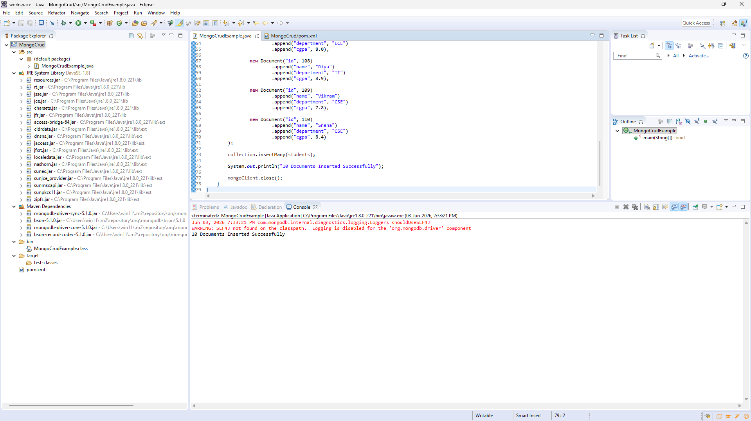
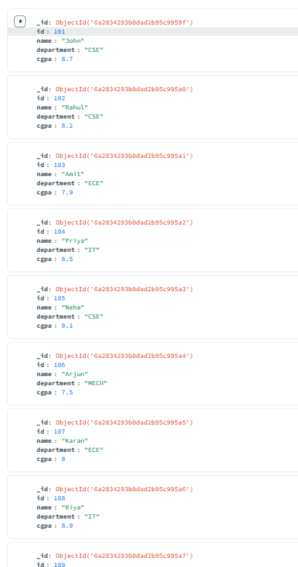
UPDATE MANY
import com.mongodb.client.*;
import com.mongodb.client.model.Filters;
import com.mongodb.client.model.Updates;
import org.bson.Document;

public class MongoCrudExample {

public static void main(String[] args) {

MongoClient mongoClient =
MongoClients.create("mongodb://localhost:27017");

MongoDatabase database =
mongoClient.getDatabase("CollegeDB");

MongoCollection<Document> collection =
database.getCollection("Students");

collection.updateMany(
Filters.eq("department", "CSE"),
Updates.set("department", "Computer Science")
);

System.out.println("Documents Updated Successfully");

System.out.println("\nUpdated Records:");

for (Document doc : collection.find()) {
System.out.println(doc.toJson());
}

mongoClient.close();
}
}
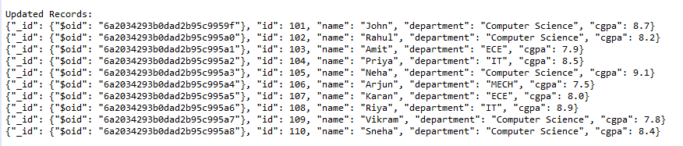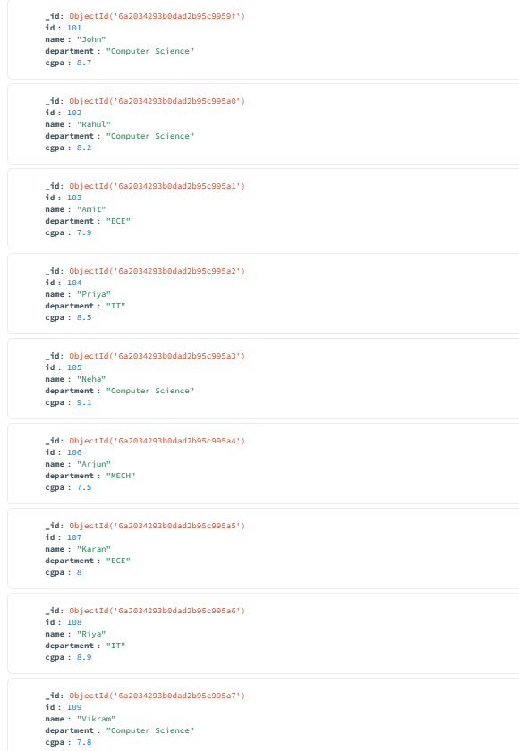
DELETE MANY
import com.mongodb.client.*;
import com.mongodb.client.model.Filters;
import org.bson.Document;

public class MongoCrudExample {

public static void main(String[] args) {

MongoClient mongoClient =
MongoClients.create("mongodb://localhost:27017");

MongoDatabase database =
mongoClient.getDatabase("CollegeDB");

MongoCollection<Document> collection =
database.getCollection("Students");

collection.deleteMany(
Filters.eq("department", "Computer Science")
);

System.out.println("Documents Deleted Successfully");

System.out.println("\nRemaining Records:");

for (Document doc : collection.find()) {
System.out.println(doc.toJson());
}

mongoClient.close();
}
}
